**DESCON ENGINEERING LIMITED**

DESCON

Descon Head Quarter 18-Km, Ferozepur Road,

P.O. Box 1201, Lahore 53000 Pakistan

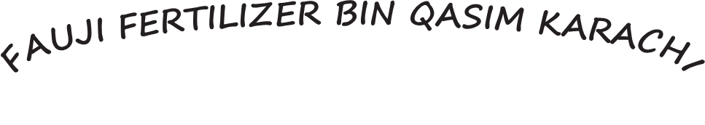

###### BMR JOBS

Phone: +92(042) 5805134

Universal Access: +92 111 DESCON

Fax: +92(o42) 5811005, 5811135

E-mail: descon@descon.com.pk Website: www.descon.com.pk

## SERVICE CERTIFICATE

Certified that Mr.

S/O Mr.

**<Name>**

**<Fname>**

Has served the Company as

**<Designation>**

Employee No . **52-3108** at

**FAUJI FERTILIZER BIN QASIM**

**FROM <From2> TO <To2>**

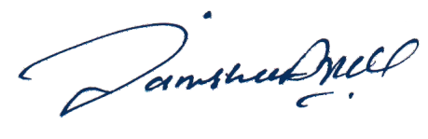

**UMMAR SHARIF**

**Project Manager**